
Ystafell Ante Room,  Neuadd Plwyf / Parish Hall,  Park Road,  Coedpoeth.  LL11 3TD  Dydd Gwener/Friday  10:30 ~ 13:00  28/04/17, 05/05/17, 12/05/17  19/05/17, 26/05/17, 02/06/17 | 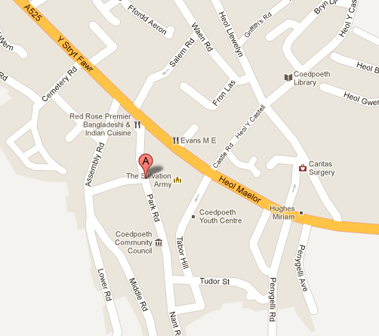
…..…………………………………………………………………………………………………………..……..

FFURFLEN YMATEB |  |  |  |  | REPLY SLIP
Hoffwn gadw lle ar y cwrs EPP Cymru a gynhelir yn: |  |  | Coedpoeth  CDSMP 2340 |  |  |  | I would like to reserve a place on the EPP Cymru course that is held at
Enw: |  |  |  |  |  |  |  | Name:
Rhif Ffôn: |  |  |  |  |  |  |  | Telephone No:
Cyfeiriad: |  |  |  |  |  |  |  | Address:
Côd Post: |  |  |  |  |  |  |  | Post Code:
Ffôn Symudol: |  |  |  |  |  |  |  | Mobile Phone:
Cyfeiriad E-bost: |  |  |  |  |  |  |  | E-mail address:
Natur y Cyflwr: |  |  |  |  |  |  |  | Nature of Condition:
A ydych yn defnyddio cadair olwyn? |  | Ydw/Yes  Nac-ydw/No  |  |  |  |  |  | Do you use a wheelchair?
Enw a rhif ffon mewn argyfwng: |  |  |  |  |  |  |  | Name and tel No. in case of emergency:
Meddygfa: |  |  |  |  |  |  |  | GP Practice:
Dychwelwch y ffurflen hon erbyn 31/03/17 at sylw:-  Cydlynydd EPP Cymru,  Bwrdd Iechyd Prifysgol Betsi Cadwaladr,  Ffordd Campbell , Caernarfon, Gwynedd  LL55 1HU   01286 674236 Fax/Ffacs: 01286 674366  Parhawch dros y dudalen |  |  |  | Please return this form by 31/03/17 for the attention of:-  EPP Cymru Coordinartor,  Betsi Cadwaladr University Health Board,  Campbell Road, Caernarfon. Gwynedd  LL55 1HU   01286 674236 Fax/Ffacs: 01286 674366  Continue over the page
 | Mae’r CDSMP yn gwrs am ddim i helpu pobl sy’n byw gyda chyflwr iechyd tymor hir i gynnal a gwella ansawdd eu bywyd trwy hunan reoli. |  |  |  |  | The CDSMP is a free course to help people who live with a long term health condition to maintain and improve their quality of life through self management.
 | Beth mae’r cwrs yn gynnwys? Chwech sesiwn wythnosol, pob un am ddwy awr a hanner (gan gynnwys lluniaeth a seibiant). Maent yn amrywiol iawn. Maent yn sgyrsiau byr, trafodaethau a sesiynau meddwl rhydd. |  |  |  |  | What does the course involve? Six weekly sessions, each lasting two and a half hours (including breaks and refreshments). They are very varied. There are brief talks, discussions and freethinking sessions.
 | Mae’r cwrs yn ymwneud â dysgu sgiliau pwysig gan gynnwys rheoli eich symptomau, delio gyda straen, iselder a hunanddelwedd isel, rheoli poen, datblygu sgiliau ymdopi, dysgu sut i ymlacio a bwyta’n iach, gweithio’n agosach gyda’r sawl sy’n gofalu amdanoch a chynllunio ar gyfer y dyfodol. |  |  |  |  | The course is about learning important skills including managing your symptoms, dealing with stress, depression and low self-image, managing pain, developing coping skills, learning ways to relax and eat healthily, working more closely with those caring for you, and planning for the future.
 | Am danoch chi /About You
Cenedl  (rhowch tic ✓) | Gwrw / Male |  |  |  | Benyw / Female |  |  |  | Arall / Other |  |  |  | Gender  (please tick ✓)
Oed  (rhowch tic ✓) | 18-24 | 25-34 | 35-44 |  |  | 45-54 |  | 55-64 |  | 65-74 |  | 75+ |  | Age  (please tick ✓)
Ethnigrwydd (rhowch tic ✓) | Gwyn  White | Du  Black |  | Asian  Asian |  |  | Tseiniaidd  Chinese |  | CymysgMixed |  | Arall  Other |  |  | Ethnicity  (please tick ✓)
Iaith Cyntaf (rhowch tic ✓) | Saesneg/English |  |  |  | Cymraeg/Welsh |  |  |  | Arall/Other |  |  |  | First Language (please tick ✓)
Dewis iaith y cwrs  (rhowch tic ✓) | Saesneg/English |  |  |  | Cymraeg/Welsh |  |  |  | Arall/Other |  |  |  | Preferred course language  (please tick ✓)
Datganwch eich prif gyflwr/ cyflyrau iechyd |  |  |  |  |  |  |  |  |  |  |  |  |  | Please state main health condition (s)
Datganwch eich prif gyflwr/ cyflyrau iechyd | Ydych chi’n ofalwr? YDW / NAC YDW  Are you a Carer? YES / NO |  |  |  |  |  |  |  |  |  |  |  |  | Please state main health condition (s)
Lle glywoch chi am EPP Cymru? |  |  |  |  |  |  |  |  |  |  |  |  |  | Where did you hear about EPP Cymru?
A oes gennych anghenion / gofynion arbennig? |  |  |  |  |  |  |  |  |  |  |  |  |  | Do you have any special needs / requirements?

