
Neuadd Eglwys Gymunedol  Community Church Hall  Moelfre  Dydd Mawrth/Tuesday  13:30 – 16:00  Cynhelir y cwrs am chwech wythnos yn olynol  The programme will run for six consecutive weeks -  25/04/17, 02/05/17, 09/05/17,  16/05/17, 23/05/17, 30/05/17. | 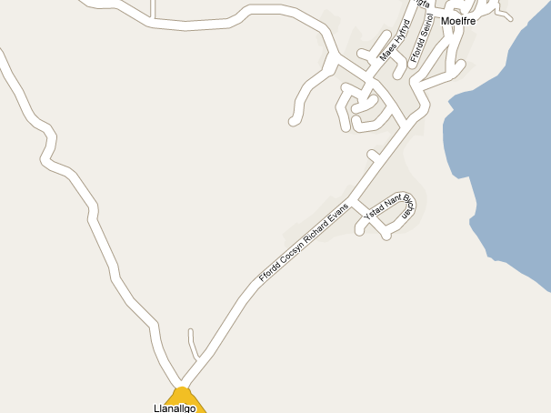
…..…………………………………………………………………………………………………………..……..

FFURFLEN YMATEB |  |  |  | REPLY SLIP
Hoffwn gadw lle ar y cwrs EPP Cymru a gynhelir yn: |  | MOELFRE  X-PERT WEST 36  |  |  | I would like to reserve a place on the EPP Cymru course that is held at
Enw: |  |  |  |  |  | Name:
Rhif Ffôn: |  |  |  |  |  | Telephone No:
Cyfeiriad: |  |  |  |  |  | Address:
Cod Post: |  |  |  |  |  | Post Code:
Ffôn Symudol: |  |  |  |  |  | Mobile Phone:
Cyfeiriad E-bost: |  |  |  |  |  | E-mail address:
Dyddiad Geni |  |  |  |  |  | Date of Birth
Rhif GIG: |  |  |  |  |  | NHS Number:
Dyddiad diagnosis: |  |  |  |  |  | Date of diagnosis:
A ydych chi’n defnyddio cadair olwyn ? | Ydw/Yes  Nac ydw/No  |  |  |  |  | Do you use a wheelchair?
Enw a rhif ffôn mewn argyfwng: |  |  |  |  |  | Name and tel No. in case of emergency:
Meddygfa Teulu: |  |  |  |  |  | GP Practice:
Parhewch dros y dudalen |  |  | Continue over the page

Mae Diabetes X-PERT yn gwrs am ddim i helpu pobl sy'n byw gyda diabetes math 2. Byddwch yn dysgu sut i reoli eich diabetes eich hun ac am y triniaethau diweddaraf sydd ar gael.  Byddwch hefyd yn cael y cyfle i archwilio problemau ydych yn eu cael gyda'ch diabetes a mynd i'r afael â nhw.  Mae Addysg Diabetes X-PERT wedi profi i  wella:  - rheoli diabetes  - lleihau meddyginiaeth diabetes  - cynyddu sgiliau hunan reoli  - gwella ffordd o fyw a safon byw | X-PERT Diabetes is a free course to help people who live with type 2 diabetes. You will learn how to self manage your diabetes and the latest treatments available.  You will also have the opportunity to explore and address problems you have with your diabetes.  X-PERT Diabetes Education has proved to improve:  - diabetes control  - reduce diabetes medications  - increase self management skills  - improve lifestyle and quality of life
 | Amdanoch chi /About You
Cenedl  (ticiwch ✓) | Gwrw / Male |  |  | Benyw / Female |  |  |  | Arall / Other |  | Gender  (please tick ✓)
Ethnigrwydd (ticiwch ✓) | Gwyn  White | Du  Black | Asiaidd  Asian |  | Tseineiadd  Chinese |  | Cymysg  Mixed |  | Arall  Other | Ethnicity  (please tick ✓)
Iaith Cyntaf (ticiwch ✓) | Saesneg  English |  |  | Cymraeg  Welsh |  |  |  | Arall  Other |  | First Language (please tick ✓)
Dewis iaith y cwrs  (ticiwch ✓) | Saesneg  English |  |  | Cymraeg  Welsh |  |  |  | Arall  Other |  | Preferred course language  (please tick ✓)
Math diabetes  (ticiwch ✓) | Math 1  Type 1 |  |  |  |  | Math 2  Type 2 |  |  |  | Diabetes type  (please tick ✓)
Ble glywoch chi am y cwrs? |  |  |  |  |  |  |  |  |  | Where did you hear about the course?
A oes gennych chi unrhyw anghenion / gofynion arbennig? |  |  |  |  |  |  |  |  |  | Do you have any special needs / requirements?

Dychwelwch y ffurflen hon erbyn 31/03/17 at sylw:-  Cydlynydd Swyddfa Hunan Ofal,  Bwrdd Iechyd Prifysgol Betsi Cadwaladr,  Ffordd Campbell , Caernarfon, Gwynedd  LL55 1HU   01286 674272 Fax/Ffacs: 01286 674366 | Please return this form by 31/03/17 for the attention of:-  Self Care Office Co-ordinator,  Betsi Cadwaladr University Health Board,  Campbell Road, Caernarfon. Gwynedd  LL55 1HU   01286 674272 Fax/Ffacs: 01286 674366

