1

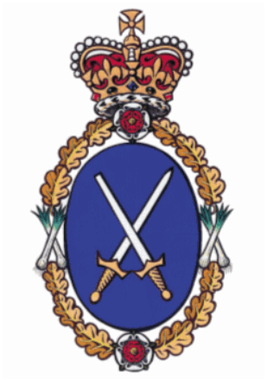

High Sheriff
of

Clwyd

Community Awards 2018

Guidance Notes and
Nomination Form

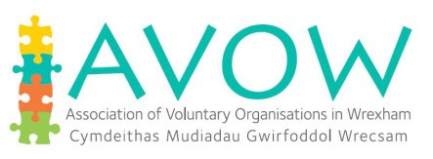
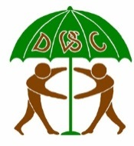
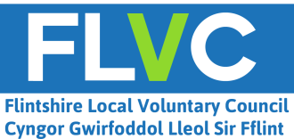
Supported by

FOREWORD

Thousands of people undertake some form of charity or voluntary work in Clwyd. This dedication and devotion underpins our communities, making for a healthier and safer society. An important part of the role of the High Sheriff is to recognise and promote the voluntary sector, with particular emphasis on those organisations that support law and order and tackle crime and social problems.

Over the past year I have met a wide range of dedicated and impressive people who go to extraordinary lengths to make a real difference in their communities. It is a pleasure and a privilege to help give them the recognition they so richly deserve. During my travels around Conwy, Denbighshire, Flintshire and Wrexham, I have realised that the role of High Sheriff is still much respected and, although it is an ancient role, it is still very relevant today.

The High Sheriff’s Award Ceremony is an opportunity for us all to acknowledge and highlight some of the outstanding work carried out by numerous people who give their precious time to so many good local causes.

To quote our great bard Shakespeare:
“I can no other answer make but thanks, and thanks, and ever thanks.”

Charlotte Howard
High Sheriff of Clwyd

Charlotte Howard

High Sheriff of Clwyd

INTRODUCTION

The High Sheriff of Clwyd Awards were launched in 2013 to recognise individuals or voluntary/ community organisations or groups (with charitable aims) that have made an outstanding contribution to their respective communities.
There will be three awards as follows:
- Two awards for individuals from each of the principal areas, namely Conwy, Denbighshire, Flintshire and Wrexham that form the preserved county of Clwyd
- One award for a voluntary/community organisation or group (with charitable aims) operating within each of the principal areas, namely Conwy, Denbighshire, Flintshire and Wrexham that form the preserved County of Clwyd.

AWARDS CEREMONY

The winners will be presented with their awards at an event to be held at Ruthin School on Friday 16th March 2018 at 6.30pm for 7.00pm.

NOMINATION PROCESS AND CONDITIONS

- Subject to the following anyone may make a nomination for their area and/or Clwyd, including people who benefit from the individual or voluntary/community group’s activities.
- You can only make one nomination.
- Individuals cannot be nominated by a partner or family member or nominate themselves.
- An individual nominee must reside in one of the four Principal Areas and be over 18 years of age.
- The nominee (whether an individual or an organisation/group) must not be contacted or made aware that they are being nominated for an award.
- Personal details provided on the nomination form may be passed to partner organisations and to the media for publicity purposes. If you don’t wish for any information to be shared in this way or if you do not wish media organisations to contact the nominee or nominator please let the appropriate County Voluntary Council know as soon as possible.
- The Judges’ decision is final and they reserve the right not to make an award.
- Nomination forms and Guidance notes can be downloaded from the appropriate County Voluntary Council website or by post.
- The closing date for the submission of completed and signed nominations to the appropriate County Voluntary Council is noon on 31st December 2017

(If you require any further information please
contact the appropriate County Voluntary Council)
COUNTY VOLUNTARY COUNCILS
Wrexham | Conwy | Denbighshire | Flintshire
High Sheriff Award  John Gallanders  Chief Officer  AVOW  Tŷ Avow  21 Egerton Street  Wrexham  LL11 1ND | High Sheriff Award  Wendy Jones  Chief Officer  Community and Voluntary Support Conwy  7 Rhiw Road  Colwyn Bay  LL29 7TG | High Sheriff Award  Helen Wilkinson  Chief Executive Officer Denbighshire Voluntary Services Council  Naylor Centre Well Street Ruthin  LL15 1AF | High Sheriff Award  Ann Woods  Chief Officer  Flintshire Local Voluntary  Council  Corlan Unit 3  Mold Business Park Wrexham Road Mold  CH7 1XP
john.gallanders@avow.org  Tel. 01978 312556 | wendyjones@cvsc.org.uk  Tel. 01492 534091 | helenw@dvsc.org.uk  Tel. 01824 702441 | ann.woods@flvc.org.uk  Tel. 01352 744000

THE HIGH SHERIFF OF CLWYD COMMUNITY AWARDS 2018

NOMINATION FORM

I/We wish to nominate the following individual/organisation for the High Sheriff of Clwyd
Community Awards 2018 for the area of * ______________________________
*insert area (e.g. Conwy, Denbighshire, Flintshire, Wrexham in respect of nominations for individuals and Clwyd for organisations)

Name of person/organisation nominated: __________________________________________
Address: ___________________________________________________________________
__________________________________________________________________________
Telephone: _________________________________________________________________
Mobile: ____________________________________________________________________
Email: _____________________________________________________________________
NOMINEE
NOMINEE

I/we wish to nominate the above named for the High Sheriff of Clwyd Community Awards 2018 for the reasons listed below.

I/we have read the eligibility criteria and agree to be bound by the conditions of entry. To the best of my/our knowledge all details are true and correct.

Name of nominator: __________________________________________________________
Organisation and Contact (if applicable): __________________________________________
Address: ___________________________________________________________________
__________________________________________________________________________
Telephone: _________________________________________________________________
Mobile: ____________________________________________________________________
Email: _____________________________________________________________________

Signature: Date: ________________________________
NOMINATOR
NOMINATOR

How do you know the person/organisation nominated?

Briefly describe the community/voluntary activities carried out by the nominee (please outline all relevant activities that you know the nominee participated in).

How long has the nominee been carrying out the above listed activities?

What is the relevance/benefit of the activities for the community?

Please give the reasons why you consider the nominee should receive a High Sheriff ’s Community Award for 2018.

Please return the completed signed nomination form to the appropriate County Voluntary Council by noon on Friday 31st December 2017
6

