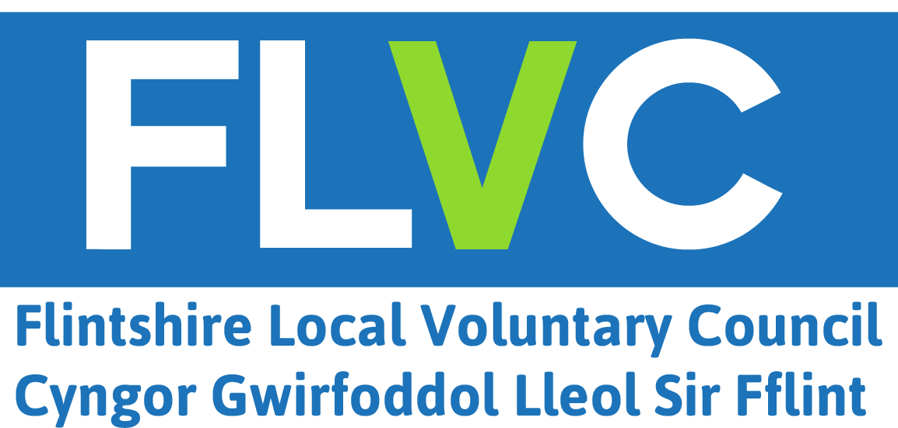

Flintshire Volunteer Centre
Unit 3, Mold Business Park, Wrexham Road, Mold, CH7 1XP
Tel: 01352 744017 Opening hours 9.00-5.00 (Mon-Thurs), 9.00-4.30 (Fri)
e-mail volunteers@flvc.org.uk

Volunteer Registration Form

This form is available in Welsh on request

Name:

Address:

Post code: Phone:

Mobile:
Contact e-mail:

Age Range (Please tick appropriate box):

14-16 17-18 19-25 25+

Areas of interest:
Administration ⁫ | Advice services  ⁫ | Advocacy ⁫ | Animals ⁫
Befriending ⁫ | Campaigning | Caring ⁫ | Children/families ⁫
Community work | Disability | Driving | Elderly
Environment | Education | Fundraising | Health
Homelessness ⁫ | Hospitals/hospices ⁫  ⁫ | Human/civil rights ⁫ | IT
Languages | Legal work ⁫ | LGBTQ+⁫ | Mental health
Management/  committee work ⁫ | Marketing/Media | Overseas ⁫  ⁫ | Prisoners/Ex-offenders
Practical/DIY ⁫ | Retail | Race/Ethnicity and Refugees | Substance misuse ⁫
Sports/Leisure ⁫ | Teaching/Training ⁫ | Arts/Culture/Heritage ⁫ | Trustees ⁫
Women’s Groups ⁫ | Youth Work | ⁫
Other information:

Have you or any members of your family ever served in the armed forces: Yes / No

Welsh speaker: Yes / No

Availability: Morning / afternoon / evening / weekend

Own transport: Yes / No

Preferred method of contact: Phone / e-mail / post

I understand that I may be required to provide references and undergo a Disclosure and Barring Service (DBS) check.

PRIVACY NOTICE

Flintshire Local Voluntary Council (FLVC) collects details, including personal data (this means any information that identifies, or could identify you). Your details will be forwarded on to the volunteering opportunities you have expressed an interest in.

We have a system of retention periods in place to ensure that your information is only stored and used for relevant purposes and/or to meet legal requirements. Where your information is no longer required, we will ensure it is disposed of in a secure manner.

Please contact us if you have any questions about our privacy policy or the information we hold about you. By email: info@flvc.org.uk or write to us at: FLVC, Corlan, Unit 3, Mold Business Park, Mold, CH7 1XP. If you feel that your personal data has been mishandled at any time you can make a complaint to the Information Commissioner’s Office by visiting their website or by calling their helpline on 0303 123 1113.

Signed: Date:

