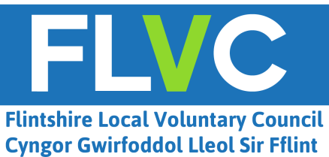

The Tom Jones Award for Outstanding Volunteering Contribution by a Young Person.
Nomination form 2020.
In honour of the late Tom Jones OBE, a founding trustee of Flintshire Local Voluntary Council for many years, we would like to recognise the work of young people volunteering in our communities.
Do you know of a young person aged between 14-25 who has made an outstanding contribution through voluntary / community work in Flintshire during 2020?

To nominate them for an award to be presented at an event planned for early 2021, please complete and submit this nomination form. Nominations close at 5pm on Friday 11th December 2020.
Your nominee must be:
- A young person aged between 14-25
and
- Volunteering for a charity, voluntary organisation or community group
and
- A resident of Flintshire, or a volunteer in Flintshire
Nominations close at 5pm on Friday 11th December 2020. Nominations received after this time may not be considered.
To submit your nomination
By email: info@flvc.org.uk
or
By post: Tom Jones Award
Flintshire Local Voluntary Council
Corlan, Mold Business Park,
Wrexham Road
Mold, Flintshire
CH7 1XP

Privacy Statement
Flintshire Local Voluntary Council (FLVC) collects the details, including any personal data (this means any information that identifies you or could identify you) for the nomination and decision making process of the Tom Jones (OBE) Award. FLVC may decide to share details written in the nomination form at the awards event.
The information will be processed in a manner that ensures appropriate security of the personal data, including protection against unauthorised or unlawful processing and against accidental loss, destruction or damage, using appropriate technical or organisational measures. Your personal data will be disposed of in a secure and timely manner after the awards event.
Please contact us (by phoning 01352744000 or emailing info@flvc.org.uk) if you have any questions about our privacy policy or information we hold about you. If you feel that your personal data has been mishandled at any time you can make a complaint to the Information Commissioner’s Office by visitng their website or calling their helpline on 0303 123 1113.

Name of young person (nominee):

______________________________________

Name of the charity, voluntary organisation or community group that the young person volunteers with:
_____________________________________

Details of person making nomination:

Name: ________________________________

Phone:________________________________

Email:_________________________________

Please write a short paragraph to explain why this young person should be recognised for their volunteer work in the Flintshire community.

